CSCI3260 Project Report

***1.Overall scene:***

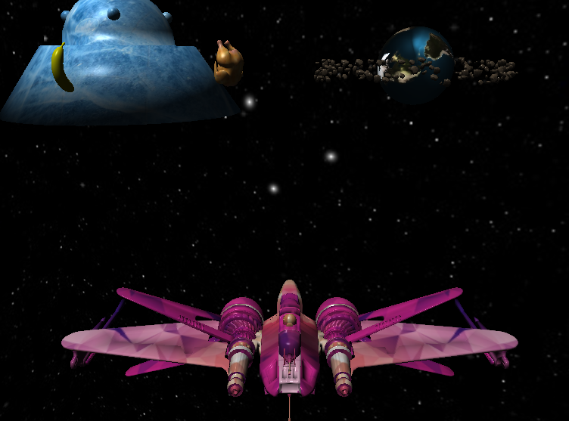

*With Both directional light and point light source:*

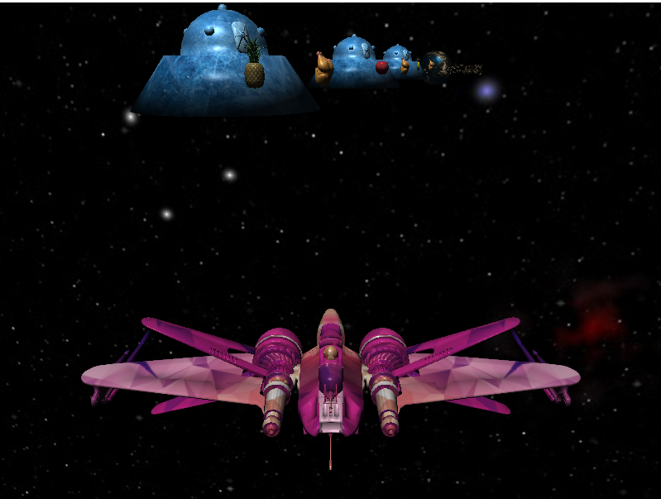

*With only point light source:*

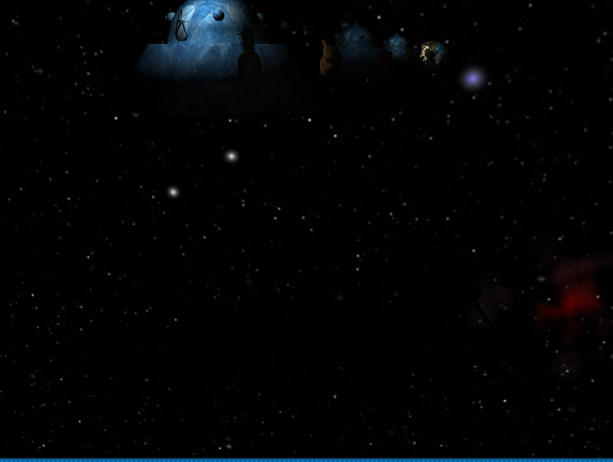

***2.Basic light rendering:***

*Alien vehicle:*

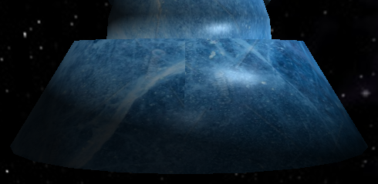

*Chicken:*

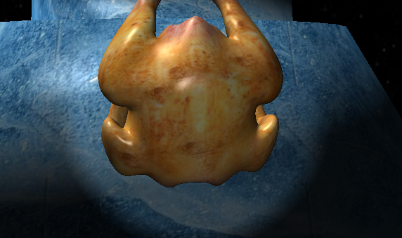

*Rocks:*

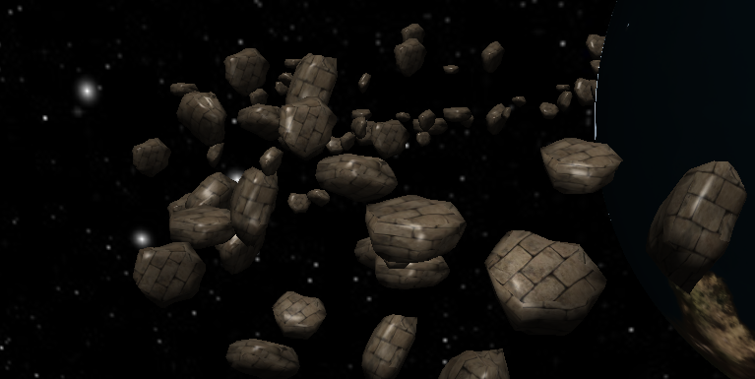

***3.***

***Collecting foods:***

*Before collecting:*

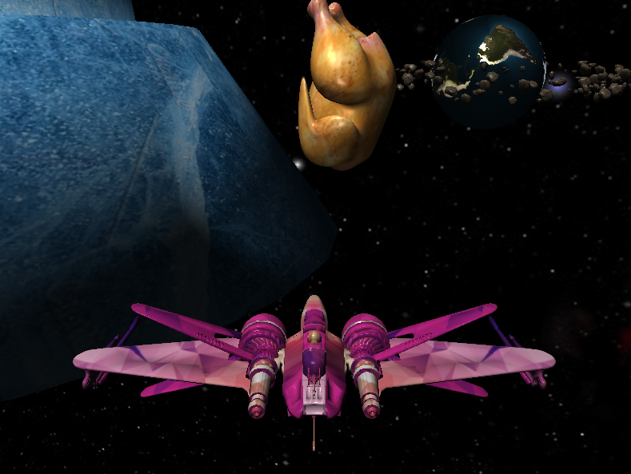

*After collecting:*

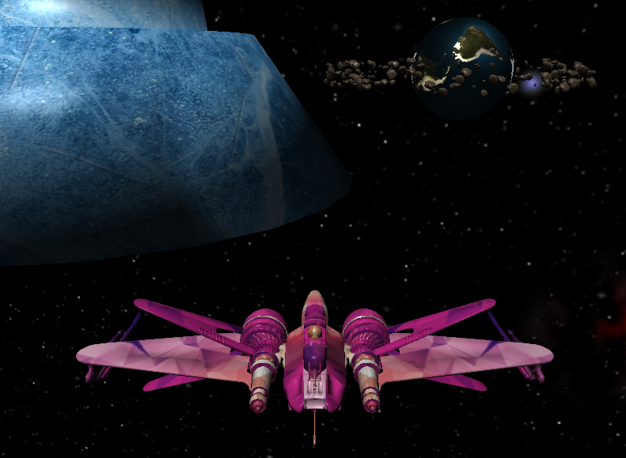

***Visiting aliens:***

*Before visit:*

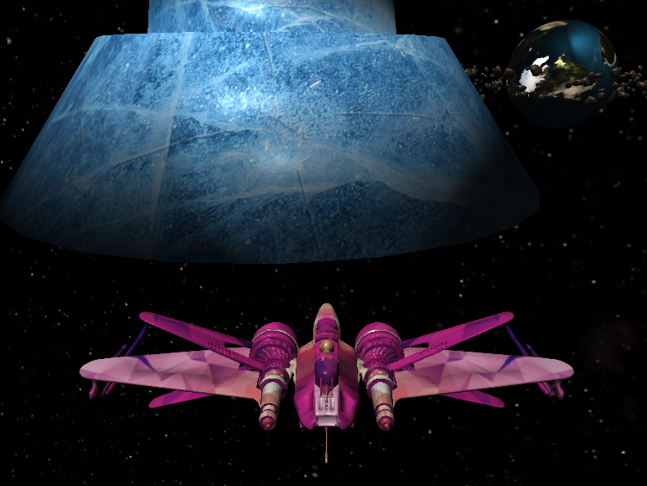

*After visit:*

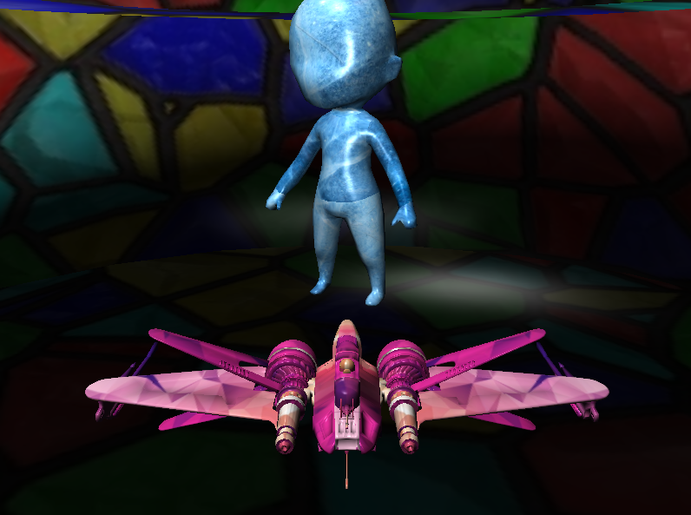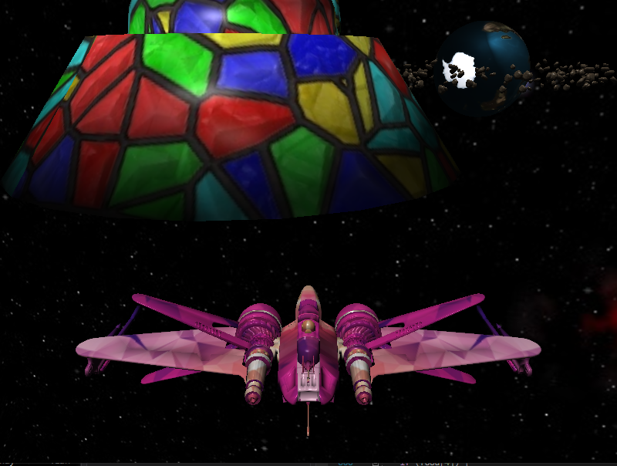

***Texture change after visiting finished:***

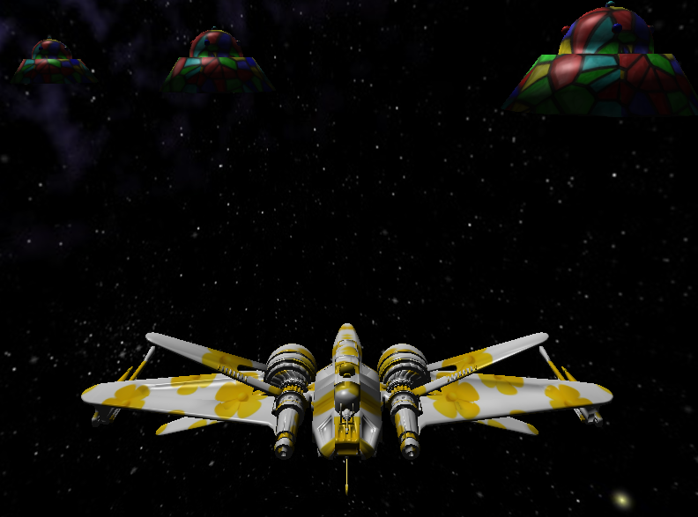

***4.Bonus features:***

*Normal Mapping:*

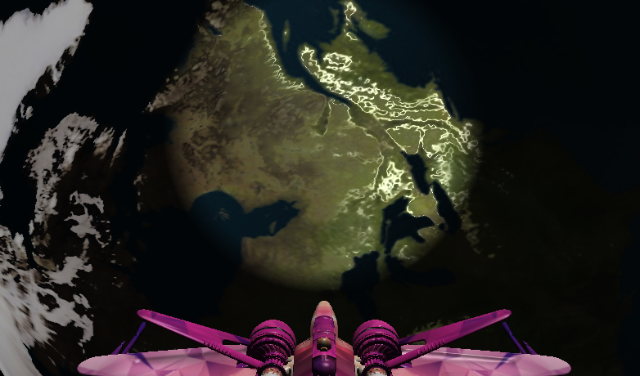

*Another light source (Spotlight):*

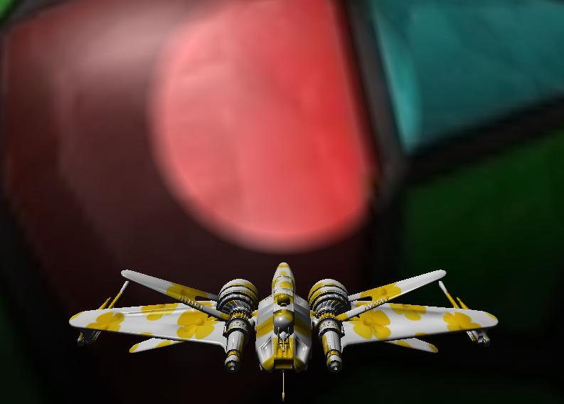

*Extra Food: Pineapple & apple & banana*

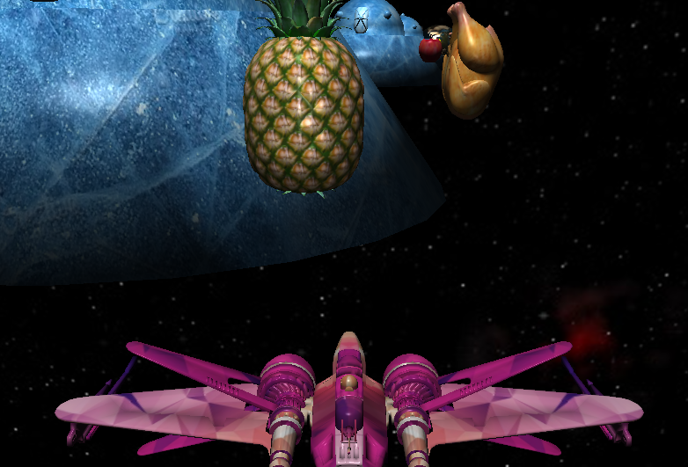 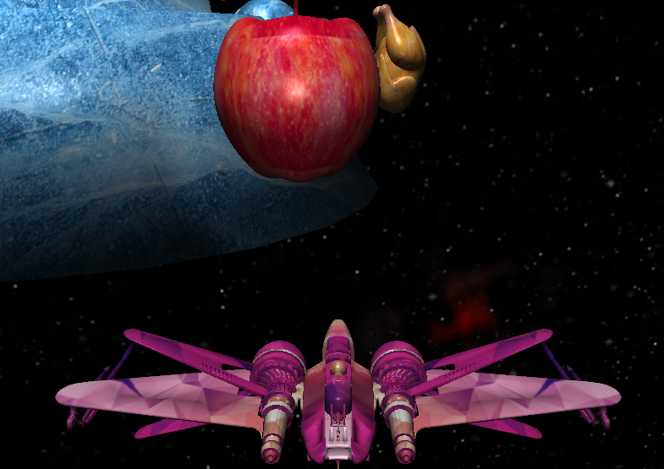 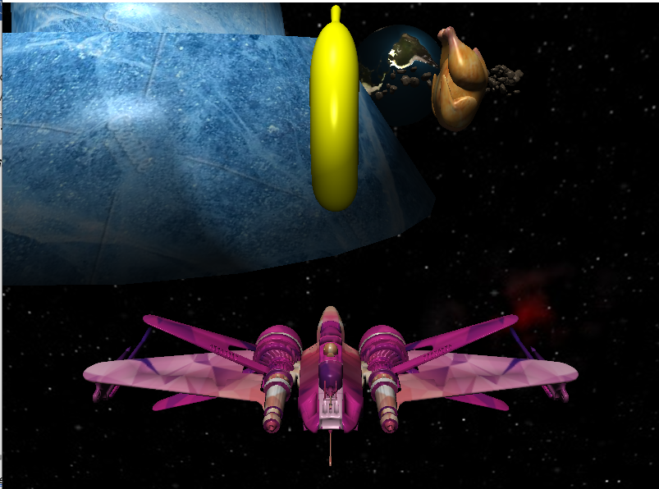

***5.Implementation details:***

***General details:***

*Interactions:*

Mouse: Move left/right: turns spacecraft left/right

Scroll up/down: zoom in/out

Keyboard: Up/down/left/right: move spacecraft

forward/backward/left/right

W/S key: increase/decrease directional light intensity

A/D key: increase/decrease point light intensity 1

Q/E key: increase/decrease point light intensity 2

*Lighting:*

Directional light: 1.

Point light: 4.

Spotlight: 1 (in front of spacecraft).

*Extra objects/texture loaded:*

Pineapple(10200_Pineapple_v1-L2.obj, 10200_Pineapple.jpg)

Apple(apple.obj, istockphoto-512401658-612x612.jpg)

Banana(banana.obj, 1200px-ICS_Quebec.svg.png)

***Specific details:***

*Skybox(for requirement 3):*

*LoadCubeMap* function used to load textures for 6 faces. Shader *skybox Vertex/Fragment shader* is used, which samples texture color directly without

lighting calculation.

*Self rotation for planet and alien vehicle(for requirement 2):*

Variable selfrotating is used to keep track of rotation angle. It increments by 0.1 each time before paintGL executes and reset to 0 when reaching 360. Rotation matrix about y axis is set with this value and applied to object planet and alien vehicle.

*Asteroid ring cloud(for requirement 5,6)*

200 asteroids in total. Model matrices with random translation/scale/ rotation are generated. Same VAO is drawn for all asteroids but with different model matrices applied each time. They are rotating around the planet with uniform circular motion.

*Collision detection(for requirement 10,11):*

Calculate the vector from camera position (near spacecraft) to object world position and use magnitude of the vector as distance.

*Normal Mapping (for bonus requirement 2):*

Normal map of the form of rgb image is passed to fragment shader as texture and rgb value is converted to (-1, 1) interval to be used as normal for later lighting calculation.